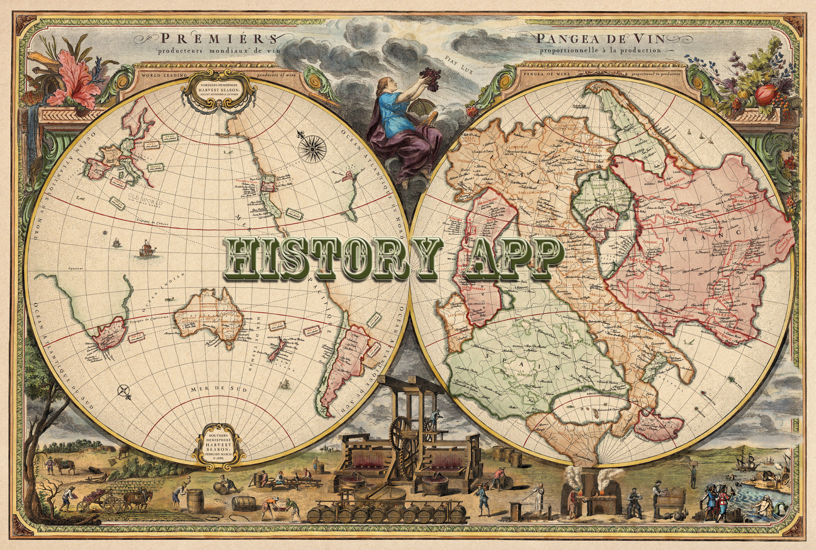

rEQUIREMENT dOCUMENT
Florida International University
Senior Project
CIS 4911
9/8/2014

Mentor:
Tracy Beeson

Development Team:
Ariel Diaz
Yesenia Yser

Copyright and Trademark Notices

I have carefully assessed the Software Requirement Document for the History App. This document has been completed in accordance with the requirements of the FIU System Development Methodology.

All materials available on this document are protected by copyright laws and international copyright treaty provisions. This material has been placed on this Internet site under the authority of the copyright owner for the sole purpose of viewing of the materials by users of this site. Users are not authorized to download or transmit any of these materials electronically, or to otherwise reproduce any of the materials in any form or by any means, electronic or mechanical, including data storage and retrieval systems, recording, printing or photocopying.
© 2014 FLORIDA INTERNATIONAL UNIVERSITY. ALL RIGHTS RESERVED

We fully accept the changes as needed improvements and authorize initiation of work to proceed. Based on our authority and judgment, the continued operation of this system is authorized.

_______________________________ _____________________
NAME DATE
Project Leader

_______________________________ _____________________
NAME DATE
Operations Division Director

_______________________________ _____________________
NAME DATE
Program Sponsor Representative

_______________________________ _____________________
NAME DATE
Program Area/Sponsor Director

Abstract

This document contains the software requirements for the History Map system. This project is one out of 18 Senior Projects for Fall 2014 at Florida International University.

These software requirements were established according to requests from the mentor, Tracy Beeson, and her passion for History. The system to be developed is for tourist and adventurers to route a historical virtual tour at a certain GPS coordinate, address, or city. This document follows the IEEE standard for a requirements specification document, with some variations.
Software Requirement Document

TABLE OF CONTENTS

Page #

1.0 INTRODUCTION
1.1 Problem Defintion
1.2 Scope
1.3 Definition, Acronyms and Abbreviations
1.4 Overview of Document 1-2
2.0 CURRENT SYSTEM
3.0 PROJECT PLAN
3.1 Project Organization
3.2 Work Breakdown 3-2
3.3 Cost 3-2
4.0 PROPOSED SYSTEM REQUIREMENTS 4-1
3.1 Functional Requirements 4-1
3.2 Analysis of System Requirements 4-1
3.2.1 Senarios 4-1
3.2.2 Use Case Model 4-1
3.2.3 Static Model 4-1
3.2.1 Dynamic Model 4-1
5.0 GLOSSARY 5-1
6.0 APPENDIX 6-1
6.1 Appendix A -- Use Cases
6-1
6.2 Appendix B – Use Case Diagrams 6-1
6.3 Appendix C – Static UML Diagram 6-1
6.4 Appendix D – Dynamic UML Diagram 6-1
6.5 Appendix E – User Interface Designs 6-1
6.6 Appendix F – Diary of meeting and tasks 6-1
7.0 REFERENCES 7-1

Introduction

Chapter 1: Introduction
History Map connects you with the past. It provides accounts of historical places and events while making it accessible at the palm of your hand. This application gets its content from the vast knowledge of many historians and their years of experience in the field. You will be able to see a map showing all of the historical places of interest around you and History Map will show you the exact address of the place, hours of operation, and phone number. It will also present you with peer-reviewed files that elaborate on the history of the place. This Android application grants you access with an archive of audio, images and documents that have been peer reviewed by professionals. History Map allows you to take a tour through your city while giving you detailed accounts of the events that once happened where you’re standing!

1.1 Problem Definition
Many systems in today’s application market provide users with an array of features for travel, such as recommended sightseeing locations, user reviews on hotels and restaurants. However there is a gap in the market for documentation on historical events and places. History Map solves this problem by giving users a connection to history in a modern and accessible way. It grants access to audio, image and document files that explain historical events in detail.

1.2 Scope
History Map will provide a collaborative database of historical sites for Historical Societies, History scholars and researchers, as well as tourists. This project will allow a user to receive information regarding nearby historical sites denoted by markers when they input a GPS coordinate or an address in their Android mobile device. Users will be able to create or access a route generated for them, which they can drive or walk by. Users have access to audio files, peer-reviewed documents, and images to learn about this site.
Information for this application will be inputted by the site admin via a Web application. To input data, the user will type in a GPS coordinate or an address and receive auto filled information and may attach a media or document file to this location. Also, the admin will have a Tasks page for organizing the work to be done.
For future development, the application will allow users to upload their own content, provide feedback, and peer review. Add on content will be emailed to the admin, who will then review the data for accuracy and either send it back to be reworked on or publish it. This application will also be developed for the iOS users and different levels of subscription will be created for users who wish to download the published document files.

1.3 Terminology
For more definitions, please see the Glossary.
iOS - is a mobile operating system developed by Apple Inc. and distributed exclusively for Apple hardware.
Android - Android is a mobile operating system (OS) based on the Linux kernel and currently developed by Google.
Web Application - is any application software that runs in a web browser and is created in a browser-supported programming language (such as the combination of JavaScript, HTML and CSS) and relies on a web browser to render the application.
Database - a comprehensive collection of related data organized for convenient access, generally in a computer.
Admin - Application content administrator.
History Map Screen - Map showing nearby historical places.
Historical Place of Interest - Place with a Map Marker on the History Map Screen.
Historical Tour - Route from place A to place B which displays Historical Places of Interest along the path.
Peer-reviewed documents - Documents that have been reviewed by history scholars.
Drafted Item - a preliminary version of a piece of writing, audio or image that is sent over to the Admin to be published.
Published Item - a finished version of a piece of writing, audio or image that was approved by the Admin and is accessible by the users.
Map Marker - A visual element that is used to mark a map point within a map.
Geolocation - the process or technique of identifying the geographical location of a person or device by means of digital information processed via the Internet.
Global Positioning System (GPS) - is a space-based satellite navigation system that provides location and time information in all weather conditions, anywhere on or near the Earth where there is an unobstructed line of sight to four or more GPS satellites.
Responsive Design - a web design approach aimed at crafting sites to provide an optimal viewing experience—easy reading and navigation with a minimum of resizing, panning, and scrolling—across a wide range of devices (from mobile phones to desktop computer monitors).

Navigation systems - A GPS-based electronic system in a car or truck that provides a real-time map of the vehicle's current location as well as step-by-step directions to a requested destination.

1.4 Overview of Document
The next chapters of this document contain current functional and nonfunctional requirements for the History Map application. Chapter 2 describes the current system with its limitation and issues. Chapter 3 presents the overall project, including the team organization, work breakdown, and the estimated cost for this project. Chapter 4 introduces the proposed system including functional and nonfunctional requirements, including use case, sequence diagrams, and UML diagrams.
Chapter 5 contains a glossary of terminology used throughout the document. Appendix A contains the current domain of use case for the project. Appendix B contains the Use case diagram based on the Use Cases going to be implemented.. Appendix C contains the static UML diagram, while Appendix D contains the Dynamic UML Diagram. Appendix E displays the current mockup for the applications interface ideas. Appendix F holds meeting minutes and task assigned from the beginning of the project. Chapter 7 includes any references used to complete this project.

Current System

Chapter 2: Current systems
This chapter will discuss current systems similar to History Explorer.
2.1 Description of Current System
Navigation systems routes a user with their current GPS location to a destination. In the user interface, an address is inputted and the device will identify, with the map, different routes for the user to take to reach the destination. Constantly tracking their GPS location, it will navigate the route depending on the user’s preference, quickest route, avoid traffic, avoid highways, etc. New models of navigation system introduce current traffic, construction, detours, and accidents. Restaurant, gas stations and auto repairs are also included and searchable via a navigation device.
These navigation systems are the building blocks of the History Map project. While they include directions, business information, hours of operations, and locations, they lack in providing educational and historical information about the location. To learn more about the history of a building, site, architecture, art, etc, a user will have to use a different device or application and research this information on their own. Now a days, most of the information placed online is not verified for accuracy, so users have to be wary of which data they consider to be accurate or not. History Map will have researched knowledge base from current historical societies, museums, researchers, and scholars.

PROJECT PLAN

Chapter 3: Project Plan
This chapter provides a detailed account of how the project will proceed, including Gantt charts, hardware requirements, and role specification. The Project Organization specifies the role assignments for each project member. Hardware and Software Requirements specify the necessary requisites to implement and operate the History Map mobile application as well as the development environment. Finally, the work breakdown utilizes these small increments to schedule the deliverables, milestones, and tasks along with their dependencies.
3.1 Project Organization
The following table displays how the roles are broken down for the current deliverable of the project.

3.1.1 Project Personnel Organization
Table 3.1.1.1 demonstrates the current project organization. Each Individual is the project manager for the other, while fulfilling functional project roles.

Team Member | Roles
Yesenia Yser | Project Manager, Functional Analyst
Ariel Diaz | Project Manager, UI Designer
Table 3.1.1.1 Project Organization

3.1.2 Hardware and Software Resources
Trello: Each individual is granted access to the Senior Project’s Trello account to organize the software development process and to identify the projects current state.
Github: Each individual is granted access to the Senior Project’s project repository to have one centralized location to coordinate on the development.
StarUML: For the creation of UML diagrams, use cases, and sequence diagrams.
Android Studio: For the development of the Android application and as well as testing and emulation of the device
Google drive: Each individual is granted access to a shared Senior Project folder, which holds documentation, presentations, UML diagrams, images, and project associated data is kept.
Google hangouts: a video chat method to communicate ideas and discuss current project status and assign task.
Webcam and microphone: Used during the google hangouts video chats and provides ease of communication
Dropbox: Each individual is granted access to a shared Senior Project folder, which holds the final draft of the documents and presentations due to formatting issues with Google Drive.
Android phone: Meant for testing purposes.
PC: Windows 7 or 8, Mac OSX, minimum of 4GB of RAM, 10GB of hard drive memory space, and minimum of 1.86GHz pc spec
Microsoft Office Suite 2010/2013: For the creation, modification, and reviewing documents and presentations.
Microsoft Project 2013: For the creation, modification and reviewing Project scheduling documents, such as GANTT Charts.
IE/Firefox/Chrome: Used to access the course, and testing the web application
Gmail: For the creation of GitHub, Trello, google drive, and drop box account, as well as communication between partners, mentor and professor.
3.2 Identification of Tasks, Milestones, and Deliverables
The project schedule created displays the goals we accomplished from Sept 1 to Sept 8, 2014. The project schedule also displays goals we wish to accomplish by the next iteration phase. See Figure 3.2.1 for detailed Gantt Chart of History Explorer’s Project Schedule.

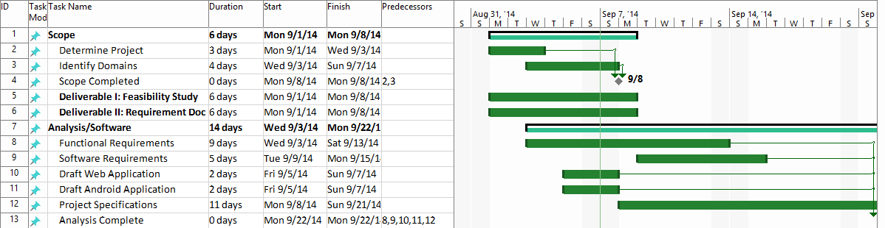
Figure 3.2.1 Detailed Project Schedule for First Draft
3.3 Cost

PROPOSED SYSTEM REQUIREMENT

Chapter 4: PROPOSED SYSTEM REQUIREMENTS
In this chapter, the features that History Explorer will implement will be further analyze. The analysis will be completed using a use case diagram that will further outlined the relationships between the users and the system. Furthermore, at the conclusion of this chapter, the client will have a further understanding of the functional requirements that our system will have.
4.1 Functional Requirements
This section contains information about the functional and non-functional system requirements. Each requirement contains the use case ID of the implemented use case.
Functional Requirements
1. The system shall allow

describes high-level functionality
Use the following format:
The system shall …
For each functional requirement state the associated non-functional requirements, if any, for Usability, Reliability, Performance, and Supportability.
4.2 Analysis of System Requirements
Analysis models – contains the complete functional specification and is mainly for the designers and programmers. This section describes the diagrams in the Appendices B - D and validates the models against the use cases.
4.2.1 Scenarios
4.2.2 Use case model
In Appendix B
    - Static model e.g., object diagrams, class diagram
    - Dynamic model e.g., sequence diagrams or state machines

GLOSSARY
iOS - is a mobile operating system developed by Apple Inc. and distributed exclusively for Apple hardware.
Android - Android is a mobile operating system (OS) based on the Linux kernel and currently developed by Google.
Web Application - is any application software that runs in a web browser and is created in a browser-supported programming language (such as the combination of JavaScript, HTML and CSS) and relies on a web browser to render the application.
Database - a comprehensive collection of related data organized for convenient access, generally in a computer.
Admin - Application content administrator.
History Map Screen - Map showing nearby historical places.
Historical Place of Interest - Place with a Map Marker on the History Map Screen.
Historical Tour - Route from place A to place B which displays Historical Places of Interest along the path.
Peer-reviewed documents - Documents that have been reviewed by history scholars.
Drafted Item - a preliminary version of a piece of writing, audio or image that is sent over to the Admin to be published.
Published Item - a finished version of a piece of writing, audio or image that was approved by the Admin and is accessible by the users.
Map Marker - A visual element that is used to mark a map point within a map.
Geolocation - the process or technique of identifying the geographical location of a person or device by means of digital information processed via the Internet.
Global Positioning System (GPS) - is a space-based satellite navigation system that provides location and time information in all weather conditions, anywhere on or near the Earth where there is an unobstructed line of sight to four or more GPS satellites.
Responsive Design - a web design approach aimed at crafting sites to provide an optimal viewing experience—easy reading and navigation with a minimum of resizing, panning, and scrolling—across a wide range of devices (from mobile phones to desktop computer monitors).

Navigation systems - A GPS-based electronic system in a car or truck that provides a real-time map of the vehicle's current location as well as step-by-step directions to a requested destination.

APPENDIX

Appendix A
This appendix contains the uses cases that our system, History Map, will implement. The uses cases listed below contain clearly depicts the interaction between the user and system from different points of view such the frequency of occurrence of the action.

Historical Search
Use Case ID | HEA002 -- HistoricalSearch
Use Case Level
Scenario | User searches for a specific historical event or place.
Actor | User
Pre-Conditions | - User has the Application installed and running on their mobile device.  - User is on the Map Screen.  - User has strong GPS signal  - User has strong Data connection
Description | - Use case begins when the user transitions into the Map Screen from the Splash Screen.  - The system shall display a search bar.  - The user fills search bar with text.  - The user taps on the Search Icon.  - The system shall receive the inputted text and display information corresponding the text inputted.  - Use case ends when the system displays the search results are displayed.
Relevant Requirements | The user must have a strong internet connection.
Post-Conditions | - The system displays the searched results.
Alternative Courses of Actions | - In step D.5, if the system loses GPS signal or Data connection for a specified duration, it will display an error message.
Exceptions | - The user has tapped on the Search icon, however the system is not processing the search request.  - The user’s Map Screen does display the information.  - The user’s Map Screen shows an incorrect result.
Related Use Case(s) | - PlayMedia  - SelectHistoricalPlaceOfInterest  - GenerateHistoricalTour
Frequency | A user will search for a historical place of interest an average of 5 times per application use session.
Risk | High. Implementing this use case requires the use of the Google Maps API with the integration of GPS services and a Data connection.
Constraints | Usability  - A user must be able to do a historical search and obtain results within 10 seconds of being in the Map Screen.  Reliability  - Mean time to Failure – 5% failures for every 24 hours of operation is within acceptable limits.  Performance  - The system shall return the search result within 3 seconds of the user having tapped the Search Icon.
Modification History
Owner | Ariel Diaz
Initiation Date | 09/07/14
Date Last Modified | 09/07/14

Download Media Files
Use Case ID | HEA003 -- DownloadMediaFiles
Use Case Level
Scenario | Download a specific Audio, Image or Document file for a specific historical place of interest.
Actor | User
Pre-Conditions | - User has the Application installed and running on their mobile device.  - User is on the Map Screen.  - User has strong GPS signal  - User has strong Data connection
Description | - Use case begins when the user transitions into the Map Screen from the Splash Screen.  - The system shall display the historical places of interest nearby.  - The user taps on the marker on top of the desired historical place of interest.  - The system shall display a popup screen with information about the place such as address, phone number, hours of operation, background info and a media category list composed of Audio, Images and Documents.  - The user taps on any of the Media categories.  - The system shall display the Media screen which contains a list of files of the selected media category in the previous step.  - The user taps on the media file that [s]he wants to download.  - The system shall then process the request and download the file from the server into the user’s mobile device.  - Use case ends when the system has finished downloading the media file and displays a download confirmation message.
Relevant Requirements | The user must have a strong internet connection.
Post-Conditions | The mobile device now has the item requested for download.
Alternative Courses of Actions | In step D.5, if the system loses GPS signal or Data connection for a specified duration, it will display an error message.
Exceptions | - The user has tapped on the Search icon, however the system is not processing the search request.  - The user’s Map Screen does display the information.  - The user’s Map Screen shows an incorrect result.
Related Use Case(s) | - PlayMedia  - SelectHistoricalPlaceOfInterest
Frequency | A user will download a media file an average of 2 times per application use session.
Risk | High. Implementing this use case requires a strong data connection and the transfer of potentially large files.
Constraints | Usability  - A user must be able to download a media file 15 seconds after having arrived at the Map Screen.  Reliability  - Mean time to Failure – 2% failures for every 24 hours of operation is within acceptable limits given that downloading files is a feature for Premium users.  Performance  - The system shall start processing the download request within 2 seconds of the user having tapped the media file to be downloaded.
Modification History
Owner | Ariel Diaz
Initiation Date | 09/07/14
Date Last Modified | 09/07/14

Play Media Files
Use Case ID | HEA004 -- PlayMediaFiles
Use Case Level
Scenario | User selects an audio file to listen to
Actor | User
Pre-Conditions | - User has the Application installed and running on their mobile device.  - User is on the Map Screen.  - User has strong GPS signal  - User has strong Data connection  - User has searched and selected a historical site on the map
Description | - Use case begins when the user selects Audio Files from the drop down options (See Figure 6.5.1).  - The system shall transition from the Map Screen to the data file screen (See Figure 6.5.2).  - The user shall select the audio file to listen to.  - The system shall retrieve the audio file from the server.  - Use case ends when the system plays the audio file.
Relevant Requirements | The user must have a strong internet connection.
Post-Conditions | - The system will play until the end of the audio file chosen.
Alternative Courses of Actions | - In step D.2, if there are no audio files available, the system shall display “Currently, no audio files available.”  - In step D.4, if the system loses GPS signal or Data connection for a specified duration, it will display an error message.
Exceptions | - The user has tapped on the Audio File, however the system is not processing the search request.  - The user’s Data File Screen does display the information.  - The user’s Data File Screen shows an incorrect result.
Related Use Case(s) | - DownloadMedia  - SelectHistoricalPlaceOfInterest  - GenerateHistoricalTour
Frequency | A user will play audio files an average of 10 times per application use session.
Risk | High. Implementing this use case requires the use of the Google Maps API with the integration of GPS services, a Data connection, Android audio permissions and database retrieval services.
Constraints | Usability  - A user must be able to select an audio file and begin to listen within 10 seconds..  Reliability  - Mean time to Failure – 5% failures for every 24 hours of operation is within acceptable limits.  Performance  - The system shall start the audio within 10 seconds of the user having tapped the Audio File Icon.
Modification History
Owner | Yesenia Yser
Initiation Date | 09/07/14
Date Last Modified | 09/07/14

Create a new historical data
Use Case ID | HEW001 -- NewHistoricalData
Use Case Level
Scenario
Actor | Admin
Pre-Conditions | - User has logged into the Web Application.  - User is on the Add Content page
Description | - Use case begins when the user transitions into the Add Content page from the Login Screen.  - The system shall display a search bar above a map. (Figure 6.5.6)  - The user fills search bar with text.  - The user taps on the Search Icon.  - The system shall receive the inputted text and display information corresponding the text inputted.  - The system displays the search results are displayed.  - The user shall select search result.  - The system shall autofill the following data: Name, Address, and Phone.  - The user shall click on the Add Media File button.  - The system shall display a File Explorer.  - The user shall select their media file and click Upload  - The system shall verify the file to be of proper format.  - Use case ends when the system generates a message to the user “New Content Successfully Added.”
Relevant Requirements | The user must have a strong internet connection.
Post-Conditions | - The system shall store the historical data within the database.  - Number of historical place of interest increment.
Alternative Courses of Actions | - In step D.5, if the system loses Data connection for a specified duration, it will display an error message.  - In step D.12, if the system cannot locate such file on the user’s machine, it will display an error message.
Exceptions | - The user has tapped on the Search icon, however the system is not processing the search request.  - The user’s Map Screen does display the information.  - The user’s Map Screen shows an incorrect result.  - The user’s file is not of correct format
Related Use Case(s) | - HistoricalSearch  - SelectHistoricalPlaceOfInterest  - GenerateHistoricalTour
Frequency | A user will add a historical place of interest an average of 5 times per day.
Risk | High. Implementing this use case requires the use of the Google Maps API with the integration of GPS services, a Data connection, and database services.
Constraints | Usability  - A user must be able to do a historical search and obtain results within 10 seconds of being in the Add Content page.  Reliability  - Mean time to Failure – 5% failures for every 24 hours of operation is within acceptable limits.  Performance  - The system shall return the search result within 3 seconds of the user having tapped the Search Icon.  - The system shall display successful message within 10 seconds of selecting Upload icon.
Modification History
Owner | Yesenia Yser
Initiation Date | 09/07/14
Date Last Modified | 09/07/14

Create Group
Use Case ID | HEW011 -- CreateGroup
Use Case Level
Scenario | Admin adds a Group to the system.
Actor | Admin
Pre-Conditions | - Admin has logged into the Web Application.  - Admin is on the Groups page
Description | - Use case begins when the user transitions into the Groups page from the Dashboard page.  - The system shall display a list of the existing groups as well as an Add Group button on the top right corner of the page.  - The user clicks on the Add Group button.  - The system shall present the Admin with a popup modal showing a Group Name input field and a Create and Cancel button.  - The Admin shall fill-out the Group Name and proceed to click on the Create button.  - The system shall process the create group request and redirect to the same Groups page.  - The Admin shall see the newly created group in the list of Groups.  - Use case ends when the system creates and displays the newly created group in the list of groups in the Groups page.
Relevant Requirements | The Admin must have a strong internet connection.
Post-Conditions | - A group has been added to the system’s list of groups.
Alternative Courses of Actions | - In step D.5, if the Admin clicks on the Cancel button the system will not process the request to create a group and shall present the Groups page.
Exceptions | - The Admin has filled-out the Group Name field and has clicked on the Create button however the system failed to process the request.
Related Use Case(s) | - CreatePermission  - AddUserToGroup  - AddPermissionToGroup
Frequency | An admin should add groups infrequently. The system shall have at most 5 different user groups.
Risk | Medium, it involves accessing and modifying the database.
Constraints | Usability  - An Admin must be able to create a Group within 5 seconds of being in the Groups page.  Reliability  - The system shall have a failure rate of less than 5%.  Performance  - The system shall create the new Group in less than 2 seconds of the Admin having clicked the Create button.
Modification History
Owner | Ariel Diaz
Initiation Date | 09/14/14
Date Last Modified | 09/14/14

Add Permission To Group
Use Case ID | HEW017 -- AddPermissionToGroup
Use Case Level
Scenario | Admin adds a specific Permission to a Group
Actor | Admin
Pre-Conditions | - Admin has logged into the Web Application.  - Admin is on the Groups page
Description | - Use case begins when the user transitions into the Groups page from the Dashboard page.  - The system shall display a list of the existing groups.  - The user clicks on a Group from the list of existing groups shown.  - The system shall present the Admin with a popup modal showing the Group Name, two tabs, one for Users and one for Permissions, as well as a Delete button.  - The Admin shall click on the Permissions tab.  - The system shall present the Admin with a list of the existing Permissions for that Group and an Add Permission button .  - The Admin shall click on the Add Permission button.  - The system shall present the Admin with a list of the Permissions that do not exist in the Group already.  - The Admin shall click on the desired permission.  - The system shall process the request to add a permission to the group and redirect the Admin to the Groups page  - Use case ends when the system has successfully added the selected permission to the selected group and redirected the Admin to the Groups page.
Relevant Requirements | The Admin must have a strong internet connection.
Post-Conditions | - A permission has been added to a selected group’s list of permissions.
Alternative Courses of Actions | - At any point from Step D.4 and D.8, the Admin could click outside of the popup modal and cancel adding the permission to the group.
Exceptions | - The Admin clicked on the group to add a permission and the system failed to display a popup modal.  - The Admin clicked on the permission to add it to a group and the system failed to add it to the group.
Related Use Case(s) | - CreatePermission  - AddUserToGroup  - CreateGroup
Frequency | An admin should add group permissions infrequently; usually at initial system setup.
Risk | Medium, it involves accessing and modifying the database.
Constraints | Usability  - An Admin must be able to add a permission to a Group within 10 seconds of being in the Groups page.  Reliability  - The system shall have a failure rate of less than 5%.  Performance  - The system shall add the permission to the Group in less than 2 seconds of the Admin having clicked the permission.
Modification History
Owner | Ariel Diaz
Initiation Date | 09/14/14
Date Last Modified | 09/14/14

Create Permission
Use Case ID | HEW013 -- CreatePermission
Use Case Level
Scenario | Admin adds a Permission to the system.
Actor | Admin
Pre-Conditions | - Admin has logged into the Web Application.  - Admin is on the Permissions page
Description | - Use case begins when the user transitions into the Permissions page from the Dashboard page.  - The system shall display a list of the existing Permissions as well as an Add Permission button on the top right corner of the page.  - The user clicks on the Add Permission button.  - The system shall present the Admin with a popup modal showing a Permission Name, a Permission Id input field and a Create and Cancel button.  - The Admin shall fill-out the Permission Name and Permission Id fields and proceed to click on the Create button.  - The system shall process the create group request and redirect to the same Permissions page.  - The Admin shall see the newly created permission in the list of Permissions.  - Use case ends when the system creates and displays the newly created permission in the list of groups in the Permissions page.
Relevant Requirements | The Admin must have a strong internet connection.
Post-Conditions | - A permission has been added to the system’s list of groups.
Alternative Courses of Actions | - In step D.5, if the Admin clicks on the Cancel button the system will not process the request to create a permission and shall present the Permissions page.
Exceptions | - The Admin has filled-out the required fields and has clicked on the Create button however the system failed to process the request.
Related Use Case(s) | - AddUserToGroup  - AddPermissionToGroup
Frequency | An admin should create permissions infrequently.
Risk | Medium, it involves accessing and modifying the database.
Constraints | Usability  - An Admin must be able to create a Permission within 5 seconds of being in the Permissions page.  Reliability  - The system shall have a failure rate of less than 5%.  Performance  - The system shall create the new Permission in less than 2 seconds of the Admin having clicked the Create button.
Modification History
Owner | Ariel Diaz
Initiation Date | 09/14/14
Date Last Modified | 09/14/14

Add User To Group
Use Case ID | HEW015 -- AddUserToGroup
Use Case Level
Scenario | Admin adds a specific User to a Group
Actor | Admin
Pre-Conditions | - Admin has logged into the Web Application.  - Admin is on the Groups page
Description | - Use case begins when the user transitions into the Groups page from the Dashboard page.  - The system shall display a list of the existing groups.  - The user clicks on a Group from the list of existing groups shown.  - The system shall present the Admin with a popup modal showing the Group Name, two tabs, one for Users and one for Permissions, as well as a Delete button.  - The Admin shall click on the Users tab.  - The system shall present the Admin with a list of the existing Users for that Group and an Add User button.  - The Admin shall click on the Add User button.  - The system shall present the Admin with a list of the Users that do not exist in the Group already as well as a search bar.  - The Admin shall click on the desired User to add to the Group.  - The system shall process the request to add a User to the group and redirect the Admin to the Groups page  - Use case ends when the system has successfully added the selected User to the selected group and redirected the Admin to the Groups page.
Relevant Requirements | The Admin must have a strong internet connection.
Post-Conditions | - A User has been added to a selected group’s list of Users.
Alternative Courses of Actions | - In step D.9, the Admin can search for the user using the Search bar and then click on the desired User to add to the group.
Exceptions | - The Admin clicked on the group to add a User and the system failed to display a popup modal.  - The Admin clicked on the User to add it to a group and the system failed to add it to the group.
Related Use Case(s) | - CreatePermission  - AddPermissionToGroup  - CreateGroup
Frequency | An admin should add group users infrequently; usually when there has been an internal error that prevented the user from creating/upgrading his/her account.
Risk | Medium, it involves accessing and modifying the database.
Constraints | Usability  - An Admin must be able to add a user to a Group within 10 seconds of being in the Groups page.  Reliability  - The system shall have a failure rate of less than 5%.  Performance  - The system shall add the user to the Group in less than 2 seconds of the Admin having clicked the user.
Modification History
Owner | Ariel Diaz
Initiation Date | 09/14/14
Date Last Modified | 09/14/14

Select Places of Interest
Use Case ID | HEA001 -- SelectHistoricalPlaceOfInterest
Use Case Level
Scenario | User searches for and retrieves historical event or place information.
Actor | User
Pre-Conditions | - User has the Application installed and running on their mobile device.  - User is on the Map Screen.  - User has strong GPS signal  - User has strong Data connection  - User has searched for a Historical Place
Description | - Use case begins when the user reviews the system results and selects a historical site marker on the map.  - The system shall search Google API for business information, such as Name, Website, Address, Phone number, and Google Photos  - The system shall search the database for historical place media files, Audio, Documents, and Photos.  - Use case ends when the system displays the search results, including API and database data.
Relevant Requirements | The user must have a strong internet connection.
Post-Conditions | - The system displays the searched results.
Alternative Courses of Actions | - In step D.2, if the system loses GPS signal or Data connection for a specified duration, it will display an error message.
Exceptions | - The user has tapped on a Historical place, however the system is not processing the search request.  - The user’s Map Screen does display the information.  - The user’s Map Screen shows an incorrect result.
Related Use Case(s) | - PlayMedia  - SelectHistoricalPlaceOfInterest
Frequency | A user will select a historical place of interest an average of 50 times per application use session.
Risk | High. Implementing this use case requires the use of the Google Maps API with the integration of GPS services and a Data connection.
Constraints | Usability  - A user must be able to obtain results within 5 seconds of selecting a marker.  Reliability  - Mean time to Failure – 1% failure for every 24 hours of operation is within acceptable limits.  Performance  - The system shall return the result within 3 seconds of the user having tapped on a historical place.
Modification History
Owner | Yesenia Yser
Initiation Date | 09/14/14
Date Last Modified | 09/14/14

Submit Feedback
Use Case ID | HEA006 -- AndroidSubmitFeedback
Use Case Level
Scenario | User submits Feedback for a specific historical place.
Actor | User
Pre-Conditions | - User has the Application installed and running on their mobile device.  - User is on the Main Page.  - User has strong GPS signal  - User has strong Data connection
Description | - Use case begins when the user selects the “Feedback” option on the Main page.  - The system shall transition the device from the Android Application and open the web browser.  - The system shall locate the web application’s feedback page.  - The system shall display the feedback web page to the user  - The user shall enter the following data in a template: Name*, Email, Historical Place, and Feedback*. (* required fields)  - The user shall select “Submit” button.  - The system verifies required field have been entered  - Use case ends when the system submits the feedback to the site admin.
Relevant Requirements | The user must have a strong internet connection.
Post-Conditions | - The system displays message, “Thank you for your feedback.”  - The system returns the user to the Android Application
Alternative Courses of Actions | - In step D.2, if the system loses Data connection for a specified duration, it will display an error message.  - In step D.7, if the user does not enter required fields, it will display an error message
Exceptions | - The user has tapped on a Feedback Option in the Main Page however the system is not processing the search request.  - The user’s Feedback Page does not display the user template.  - The Submit button on the Feedback Page does not process the data.
Related Use Case(s) | 1. WebAppFeedbackPage
Frequency | A user will provide feedback on a historical place of interest an average of 2 times per application use session.
Risk | High. Implementing this use case requires the use of a Data connection.
Constraints | Usability  - The system shall display the feedback page within 10 seconds of selecting Feedback on the Main Page.  - A user must be able to feedback within 5 seconds of selecting submit button.  Reliability  - Mean time to Failure – 1% failure for every 24 hours of operation is within acceptable limits.  Performance  - The system shall display success message within 3 seconds of user selecting Submit button.  - The system shall return to the Android App within 10 seconds of the user confirming feedback was submitted.
Modification History
Owner | Yesenia Yser
Initiation Date | 09/14/14
Date Last Modified | 09/14/14

RecommendRoute
Use Case ID | HEA007 -- RecommendRoute
Use Case Level
Scenario | User recommends a specific historical route.
Actor | User
Pre-Conditions | - User has the Application installed and running on their mobile device.  - User is on the Map Screen.  - User has strong GPS signal  - User has strong Data connection  - User has generated a route.
Description | - Use case begins when the user selects the “recommend” option on the Map Screen.  - The system shall display a message with two options: “Do you want to recommend this route?”, “Yes”, “No”.  - The user shall select “Yes” option.  - The system shall submit the recommended route.  - Use case ends when the system stores the route as a “trending route”
Relevant Requirements | The user must have a strong internet connection.
Post-Conditions | - The system displays message, “Thank you for your recommendation!”  - The system shall increment historical places “likes” by one.
Alternative Courses of Actions | - In step D.2, if the user selects “No”, the system will return to the Map Screen with the last results  - In step D.4, if the system loses Data connection for a specified duration, it will display an error message.
Exceptions | - The user has tapped on a Recommend button in the Map Page however the system does not display message.
Related Use Case(s) | 1. RecommendAHistoricalPlace
Frequency | A user will recommend a historical route an average of 2 times per application use session.
Risk | High. Implementing this use case requires the use of a Data connection.
Constraints | Usability  - The system shall display the Acceptance message within 3 seconds of selecting Recommend on the Map Page.  - A user must be able to recommend a route within 1 seconds of selecting Yes option button.  Reliability  - Mean time to Failure – 1% failure for every 24 hours of operation is within acceptable limits.  Performance  - The system shall return to the Map Screen within 1 seconds of the user selecting Yes
Modification History
Owner | Yesenia Yser
Initiation Date | 09/14/14
Date Last Modified | 09/14/14

SelectTrendingRoute
Use Case ID | HEA009 -- SelectTrendingRoute
Use Case Level
Scenario | User selects a trending route to follow
Actor | User
Pre-Conditions | - User has the Application installed and running on their mobile device.  - User is on the Trending Screen.  - User has strong GPS signal  - User has strong Data connection
Description | - Use case begins when the user transitions from the Map Screen to the Trending Screen.  - The system shall display current trending routes and places.  - The user shall select a route to follow  - The system shall transition from the Trending Screen to the Map screen.  - The system shall display the selected route on the Map Screen.  - The system shall display confirmation message, “Do you want to navigate through this route?”  - The user shall select “yes” option.  - Use case ends when the system displays the first historical place via closest to their GPS Location.
Relevant Requirements | The user must have a strong internet connection and GPS Signal.
Post-Conditions | - The system displays dropdown menu items for the first historical place
Alternative Courses of Actions | - In step D.4, if the system loses Data connection for a specified duration, it will display an error message.  - In step D.7, if the user selects “No”, the system will return to the Map Screen with the last results
Exceptions | - The user has tapped on a Trending Option in the Main Page however the system does not transition to Trending Screen  - There is no data within the Trending Screen  - The user has selected a Trending route, however the system does not transition to the Map Screen
Related Use Case(s) | 1. RecommendAHistoricalPlace  2. SelectTrendingRoute
Frequency | A user will select a trending historical route an average of 2 times per application use session.
Risk | High. Implementing this use case requires the use of a Data connection and GPS Signal.
Constraints | Usability  - The system shall transition to the Trending Screen within 3 seconds of selecting the Trending Option on the Main Screen.  - The system shall transition to the Map Screen within 3 seconds of selecting the Trending route on the Trending Screen.  Reliability  - Mean time to Failure – 2% failure for every 24 hours of operation is within acceptable limits.  Performance  - The system shall generate the route to the Map Screen within 1 seconds of the user selecting the Trending Route
Modification History
Owner | Yesenia Yser
Initiation Date | 09/14/14
Date Last Modified | 09/14/14

Save My Route
Use Case ID | HEA011 -- SaveMyRoute
Use Case Level
Scenario | User specifics a touring route from a starting point
Actor | User
Pre-Conditions | - User has the Application installed and running on their mobile device.  - User is on the Map Screen.  - User has strong GPS signal  - User has strong Data Connection  - User has selected their starting point
Description | - Use case begins when the user has selected their hotel location.  - The system shall generate a dropdown scrolling menu with relevant places of interest nearby.  - The user shall selected the clickbox for each site they desire to visit.  - The user shall select “Generate My Route”  - The system shall display a route.  - The user shall select “save my route” button.  - Use case ends when the system stores the route into the user’s account.
Relevant Requirements | - The user must have a strong internet connection.  - The user must have selected a start location such as a hotel.
Post-Conditions | - The system stores their generated route to the MyRoutes Page.  - The system generates a checklist of each site.
Alternative Courses of Actions | - In step D.2, D.4 and D.6, if the system loses GPS signal or Data connection for a specified duration, it will display an error message.
Exceptions | - The user has tapped on a click box for a place of interest but does not check it off  - The user’s Map Screen does not display the information.  - The user’s drop down Screen shows an incorrect result.  - The system does not store the route
Related Use Case(s) | - SelectHistoricalPlaceOfInterest  - GenerateHistoricalTour
Frequency | A user will search for a historical place of interest route an average of 5 times per application use session.
Risk | High. Implementing this use case requires the use of the Google Maps API with the integration of GPS services and a Data connection.
Constraints | Usability  - A user must be able to do a historical route search and obtain results within 10 seconds of selecting their current location.  Reliability  - Mean time to Failure – 5% failures for every 24 hours of operation is within acceptable limits.  Performance  - The system shall return the search result within 3 seconds of the user having tapped the Search Icon.
Modification History
Owner | Yesenia Yser
Initiation Date | 09/21/14
Date Last Modified | 09/21/14

Submit Feedback
Use Case ID | HEW004 -- SubmitFeedback
Use Case Level
Scenario | External user provides feedback through the web application
Actor | External user
Pre-Conditions | External user has logged into the Web Application.
Description | - Use case begins when the external user logs into the web application for History Explorer.  - The system shall present the external user with a page with fields to provide feedback.  - The external user fills out a feedback title and body and clicks on a Send button.  - The system shall process the send feedback request, clear the fields and present the user with a message displaying the status of the sent feedback.  - Use case ends when the external user views the displayed message regarding the status of the sent feedback.
Relevant Requirements | The External user must have a strong internet connection.
Post-Conditions | The Feedback database table now contains a new entry.
Alternative Courses of Actions | In step D.3, if the external user clicks on Cancel, the feedback will not be sent and the page will clear.
Exceptions | The external user has filled-out the fields to provide feedback and has clicked on the Send button however the system failed to process the request and the feedback was never sent.
Related Use Case(s) | - AndroidSubmitFeedback
Frequency | Feedback should be provided frequently (about 5 times a week).
Risk | Medium, it involves accessing and modifying the database.
Constraints | Usability  - An external user must be able to create and send feedback within the first 30 seconds of the user being in the feedback page.  Reliability  - The system shall have a failure rate of less than 5%.  Performance  - The system shall process the feedback within 3 seconds or the external user having clicked on Send or Cancel.
Modification History
Owner | Ariel Diaz
Initiation Date | 09/27/14
Date Last Modified | 09/27/14

Get Help About Current Page
Use Case ID | HEW005 -- GetHelpAboutCurrentPage
Use Case Level
Scenario | User is confused about the functionality of the page and would like further details.
Actor | User (External or Admin).
Pre-Conditions | User has logged into the Web Application.
Description | - Use case begins when the user clicks on the Help button at the top right corner of any of the pages in the web application.  - The system shall provide the user with a message explaining the purpose of the page.  - The user closes the message displayed by the system by clicking on the Close button.  - Use case ends when the user closes the message displayed by the system.
Relevant Requirements | The user must have a strong internet connection.
Post-Conditions | The user is no longer confused about the purpose of the current page in the web application.
Alternative Courses of Actions | In step D.3 the user could click away from the message and the message would be closed.
Exceptions | The user has clicked on the Help button, however the system failed to load the message for that page from the database.
Related Use Case(s) | None
Frequency | The design revolves around user experience, therefore, the use of this case is to be infrequent.
Risk | Low, it involves accessing the database.
Constraints | Usability  - A user must be able to find help regarding the functionality of the page within 3 seconds of searching for help.  Reliability  - The system shall have a failure rate of less than 2%.  Performance  - The system shall display a help message within a second of the user having clicked on the Help message.
Modification History
Owner | Ariel Diaz
Initiation Date | 09/27/14
Date Last Modified | 09/27/14

Appendix B
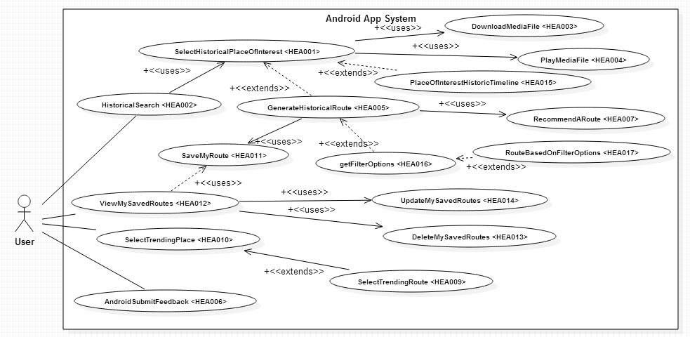
Figure 4.2.2.1 Android Application System Use Case Diagram
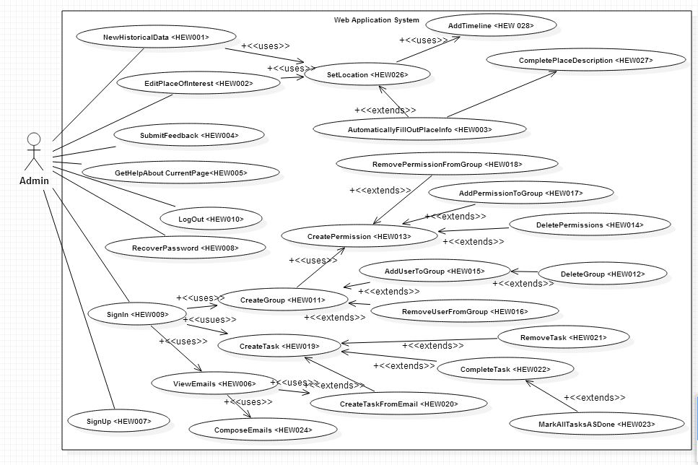
Figure 4.2.2.2 Web Application Use Case Diagram
Appendix C
Static UML diagram
Appendix D
Dynamic UML diagrams

Appendix E
This appendix includes mockup interface ideas for the current project.
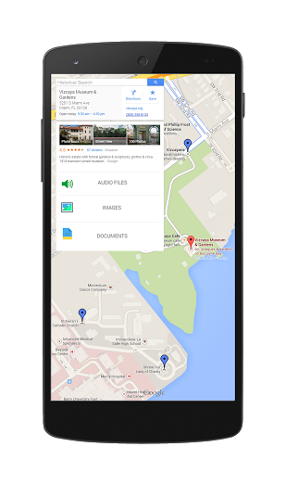 | 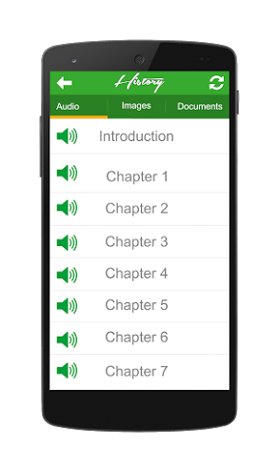
Figure 6.5.1 History App Mockup Historical Site Marking Interface | Figure 6.5.2 History App Mockup Data Files Interface
 | 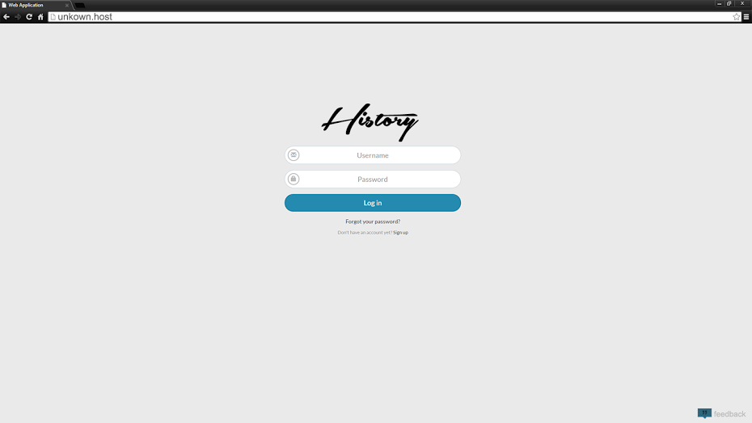
Figure 6.5.3 History App Splash Screen Interface | Figure 6.5.4 History App Web Application Login Screen Interface
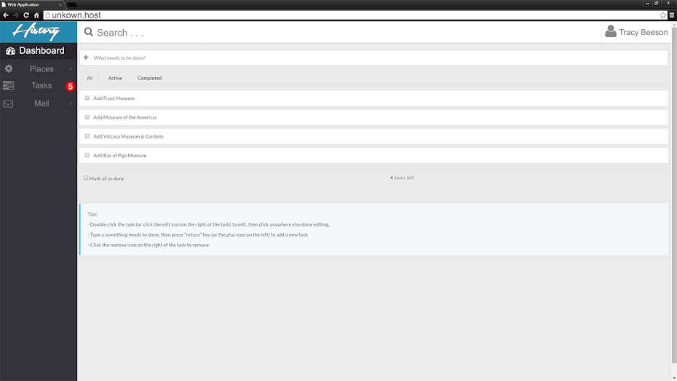
Figure 6.5.5 History App Web Application Admin Task List

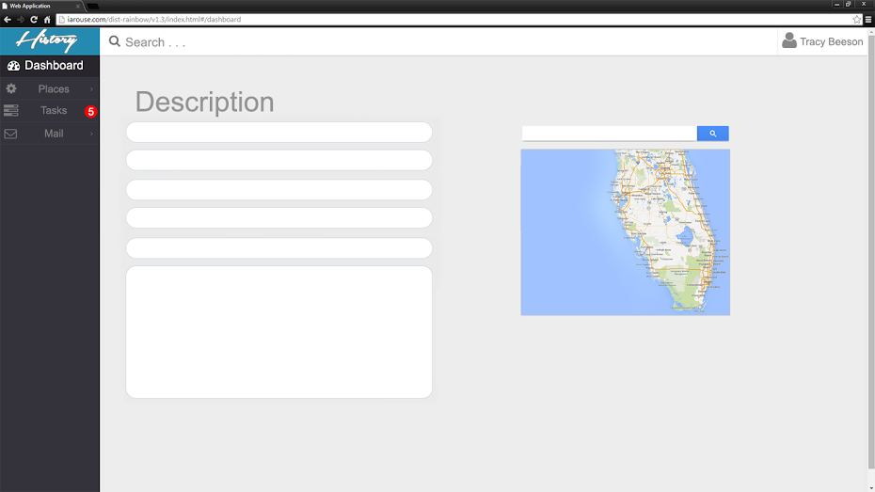
Figure 6.5.6 History App Web Application Admin Add Content
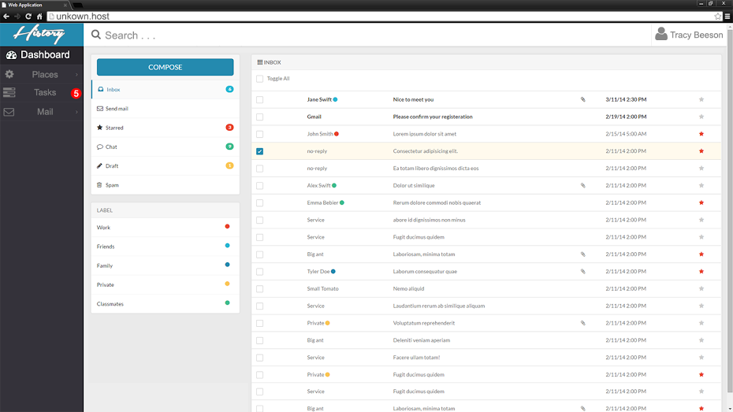
Figure 6.5.7 History App Web Application Admin Email Accessibility

Appendix F
This appendix includes all documented group meetings diary. Each diary consist of partners that arrived for the meeting, date and time, the agenda, a discussion of each individual's task and an overview of what was accomplished.

MINUTES
Meeting Date 9/3/2014
Time 6:15 PM
Meeting location JCCL in ECS
Meeting called by Yesenia Yser
Type of meeting Requirement/Analysis

Facilitator Yesenia Yser
Note Taker Ariel Diaz
Timekeeper Ariel Diaz

Attendees
Tracy Beeson
Ariel Diaz
Yesenia Yser

AGENDA TOPICS
Time allotted 1 hour 25 minutes
Agenda topic Requirement Analysis

Discussion:
Tracy was asked questions regarding the purpose and scope of the project. The project would not be based on an already existing application, meaning that it is to be built from scratch. The platform chosen to host the app is Android, however, a web application is to be created to manage the content to be displayed in the Android app. Content is to be added manually by the site admins. Yesenia and I are not expected to provide content for the application. Tracy wants an Android application that uses Google Maps to display historical items such as pieces of writing, images and sounds in specific locations in the map. A tour functionality is to be added. This would allow the users to follow a route which will provide them with information about historical events and places in the vicinity. The main user base is composed by tourists and historical societies/museums. Although in the future the app would expand to accommodate for professors by providing a way for them to peer review the existing historical items. Tracy plans to earn money through the application by enforcing a user subscription fee for those that would like to download the historical content being shown. We are expected to implement the database, data access, server file storage, android app and admin web app.
Conclusion:
-New application.
-Platform: Android and Web Application.
-Required Functionalities:
-Admins can manage content using the web app.
-Android app users can view historical items in the map
-Android app users can read/view/listen to the items pertaining to a historical event/location.
MINUTES
Meeting Date 9/6/2014
Time 12:30PM
Meeting location Google Hangouts
Meeting called by Ariel Diaz
Type of meeting Current Progress

Facilitator Ariel Diaz
Note Taker Yesenia Yser
Timekeeper Ariel Diaz

Attendees
Ariel Diaz
Yesenia Yser

AGENDA TOPICS
Time allotted: 25 minutes
Agenda topic Stand Up

Discussion:
Ariel Diaz has been working on the mock up interfaces for the History App, both Android and Web application. Yesenia Yser has been working on the Documentation, setting up the formatting of the document, working on milestones and a breakdown of workload, including the GANNT Chart. Trello has been updated with current tasks both members need to accomplish, from Documentation, Project environment, Web, and Android. Yesenia has also contacted the Mentor with the information to setup Trello and Github account. Features/ Use Case document has been created on the Google drive shared folder, split with Web and Android features and questions to be discussed later. Documentation was split already and identified on Trello. We will re-meet at 6:30PM to discuss the features and split the Use cases.
Conclusion:
-Re-meeting at 6pm for updates on current progress, regroup, and split the discuss Use cases
-Brainstorm Functional Requirements
-Ariel will create the Mock up Interfaces for the Web application
-Split the documentation -- See Trello “Documentation: First Draft - SRD” in Checklist, each of us placed name next to the section we wish to complete
-Split the Feasibility Study Documentation -- See Trellow “Documentation: First Draft -- FS” In checklist, each of us placed the name next to the section we wish to complete.
-Contacted Mentor for Trello and Github account creation
MINUTES
Meeting Date 9/8/2014
Time 6:15 PM
Meeting location JCCL in ECS
Meeting called by Tracy Beeson
Type of meeting Requirement/Analysis
Facilitator Yesenia Yser
Note Taker Ariel Diaz
Timekeeper Ariel Diaz

Attendees
Tracy Beeson
Ariel Diaz
Yesenia Yser
AGENDA TOPICS
Time allotted 1 hour
Agenda topic Requirement Analysis

Discussion:
After our senior project presentation and receiving feedback from Sadjadi and Juan Caraballo, we met with the Client, Tracy, to demonstrate our current mock up and ask about what new features she would like. Tracy currently liked the current mock up, however, due to the new features, these mock ups are changing as well.
We discussed the different platforms this application can be hosted on: Total Web Application, Hybrid application (For both Android and OS) or Native Platform (Android, iOS, and Web in its native form).
We also discussed the current features we will like to add:
- Recommend a site or route
- Trending Route or site
- User groups and permissions
- Task/to - do list on web application
Client was not sure of the technical details and wished to have an email with this technical details so she can research. Ariel Diaz will be sending out an email where he will explain with further details what having the project in those platforms means at a high level.
Name change was also discussed since there has not been a set name for the project. Informing Tracy that the current project being open source. These concerns and comments are in the email communication between Ariel and Tracy
Conclusion:
- Email Client with technical details for new platform and features
- Names for Application:
  - History Map
  - History Hunter
  - History Globe
  - City History
  - World History
  - History Market
  - Know your History
  - Map your History
- Admin Dashboard
  - Listing the following items:
    - Users and the functionality of upgrading their accounts
    - Popular places of interest near you.
    - Related places of interest to add to the database.
    - Statistical data regarding views for every place, and document.
    - Statistics regarding a rating system for places and documents.
- Create new Mockups to include new features
- Create use cases for new features after client approves.
MINUTES
Meeting Date 9/14/2014
Time 11:00 AM
Meeting location Google Hangouts
Meeting called by Ariel Diaz
Type of meeting Standup; New Task

Facilitator Ariel Diaz
Note Taker Ariel Diaz
Timekeeper Yesenia Yser

Attendees
Ariel Diaz
Yesenia Yser
AGENDA TOPICS
Time allotted 30 minutes
Agenda topic Standup; Assign new Task

Discussion:
Over the course of the meeting we introduced the idea of Groups, Permissions and the interaction between one another and Users of the History Explorer. We reached the conclusion that for this project we shall have use cases for creating Groups.

Each group will contain a user base as well as a set of permissions that will translate into the users being able to access different content such as the media made available by the Admins. I, Ariel, wrote the use cases for the following use cases: CreateGroup, CreatePermission, AddUserToGroup, AddPermissionToGroup.

Yesenia brought up the idea of having the functionality to recommend a specific historical route. It would basically allow the user to recommend a historical route which they have traveled through. Another idea that Yesenia brought up to the table was that of having a trending route to follow. The system basically analyzes database data and selects trending routes amongst our users and presents them to others. Use cases were written correspondingly.
Conclusion:
  - Statistical data regarding views for every place, and document.
  - Statistics regarding a rating system for places and documents.
  - Groups, Permissions and Users
  - New Features still need to be approved by client
  - Client meetings are set for
  - Task to be done By Monday Presentation:
    - Ariel
      - Finalize the current mockups
      - Write two more use cases
      - In FS document, 1.3
      - In RD, 3.3
      - Review and Unify current Use cases
    - Yesenia
      - Write two more Use Cases
      - Use Case diagram
      - Update Gantt Chart to include up to next presentation
      - In FS doc, 3.2
      - In RD, 3.2
      - Add new diary meetings to the final document
    - Together:
      - Subsystem breakdown
      - In FS,
        - 2.3 - 2.5
      - In RD,
        - Chapter 4
MINUTES
Meeting Date 9/15/2014
Time 2:00 PM
Meeting location JCCL ECS
Meeting called by Yesenia Yser
Type of meeting Standup; New Task
Facilitator Yesenia Yser
Note Taker Ariel Diaz
Timekeeper Yesenia Yser

Attendees
Ariel Diaz
Yesenia Yser
AGENDA TOPICS
Time allotted 30 minutes
Agenda topic Assign new Task

Discussion:
Ariel has been communicating with Tracy in regards with the new application name and informing her about the open source, answering any questions or concerns she may have. Nothing here has been finalize, more details will be posted when they are available. More details will be discussed via email or 9/22 after our Senior Project presentation.

During this meeting, we discuss this week task that should be completed by Monday’s presentation. Currently we will be doing Google hangouts or text chats to keep each one of us posted on the others current status or issues. An in person meeting is still in discussion for this weekend.
Conclusion:
  - New Features still need to be approved by client
  - Client meetings are set for via Google Calendar
  - Task to be done By Monday Presentation:
    - Ariel
      - Finalize the current mockups
      - Write two more use cases
      - In FS document, 1.3
      - In RD, 3.3
      - Review and Unify current Use cases
    - Yesenia
      - Write two more Use Cases
      - Use Case diagram
      - Update Gantt Chart to include up to next presentation
      - In FS doc, 3.2
      - In RD, 3.2
      - Add new diary meetings to the final document
    - Together:
      - Subsystem breakdown
      - In FS,
        - 2.3 - 2.5
      - In RD,
        - Chapter 4
    - Practice Presentation:
      - Take an hour from our meeting to finalize our presentation
      - Each individual is timed based on the standards Sadjadi has placed for presentation
      - Give each other pointers on what to focus on
      - Get a flow setup depending on who presents first
      - Make sure each individual is able to present their current status within the allocated time.
MINUTES
Meeting Date 9/22/2014
Time 6:30 PM
Meeting location ECS
Meeting called by Yesenia Yser
Type of meeting: Recurring Presentation Recap with Tracy Beeson
Facilitator Yesenia Yser
Note Taker Ariel Diaz
Timekeeper Ariel Diaz

Attendees
Ariel Diaz
Yesenia Yser
Tracy Beeson
AGENDA TOPICS
Time allotted 1 hour
Agenda topic Discuss presentation feedback with Tracy Beeson

Discussion:
- During this meeting we presented Tracy with the deltas since our last meeting. New features that we introduced are the planning of a vacation using History Explorer as well as having a timeline for a specific task. She approved both the Android application mockup and the web application mockup. Regarding tackling a heavier challenge, Tracy told us that she would get back at us after speaking with her most tech savvy colleagues and finding out about a cool feature for the product to have. We also spoke about the feedback flow from the user to the admin and she was pleased. During this meeting we also discussed the idea of having the system generate a tour based on a location. Advertisement placing was also discussed.
Conclusion:
- Tracy will contact technology savvy historians and ask them for recommendations on a more challenging feature.
- Tags shall be introduced for Tasks.
- Add Search bar to tasks
- Tracy will provide us with a reliable source where to pull data from.
- We have Tracy’s approval on the new features since our last meeting with her:
  - Vacation Route
  - My Saved Routes
  - Timeline
  - Using social media and other sources to populate a timeline.
- Look into Advertising placing for the Android application.
MINUTES
Meeting Date 9/26/2014
Time 12:00 PM
Meeting location JCCL ECS
Meeting called by Ariel Diaz
Type of meeting: Progress Report

Facilitator Ariel Diaz
Note Taker Ariel Diaz
Timekeeper Yesenia Yser
Attendees
Ariel Diaz
Yesenia Yser
AGENDA TOPICS
Time allotted 45 minutes
Agenda topic: Current Status; Next Steps

Discussion:
- Ariel has been working on designing the database schema to support users, groups, permissions, places of interest, timelines, events and the relationships among them. He has also been writing documentation and writing use cases to match the system’s functionality.
- Yesenia has been working on the live Android mockups, as well as making sure the writing of the documentation keeps moving forward with the respective use cases. She has been working to finalize the requirements for her main feature.
- We discussed how to approach the next presentation. We talked about what to present and in what order.
- We also discussed what we will be doing on the weekend. During the weekend we will finalize all of our features and prioritize them in our board. Once the list of features are final we will write the use cases to match the list.
Conclusion:
- For this meeting, Yesenia and I caught up on what each one of us has been doing, and we sorted out what our next steps are. We also went over what we will be working on during the weekend.
MINUTES
Meeting Date 9/27/2014
Time 12:00 PM
Meeting location Google Hangout
Meeting called by Ariel Diaz
Type of meeting: Standup
Facilitator Ariel Diaz
Note Taker Ariel Diaz
Timekeeper Yesenia Yser

Attendees
Ariel Diaz
Yesenia Yser
AGENDA TOPICS
Time allotted 15 minutes
Agenda topic: Plans for today

Discussion:
- By the end of today, we should have written 3 uses cases each for the functionalities that we will implement. Each one of use will tackle a chapter of documentation regarding the feasibility study document.
- We will both finalize the list of features for this project.
- Ariel will finalize the database schema design.
- Yesenia will update the Gannt Chart for this period in the project. She will also start development on the Android side of the project.
Conclusion:
- This was a short meeting about what will be done by the end of Saturday 9/27/2014 on our side.
MINUTES
Meeting Date 9/28/2014
Time 10:00 PM
Meeting location JCCL ECS
Meeting called by Yesenia Yser
Type of meeting: Deployment
Facilitator Yesenia Yser
Note Taker Ariel Diaz
Timekeeper Yesenia Yser

Attendees
Ariel Diaz
Yesenia Yser
AGENDA TOPICS
Time allotted 3 hours
Agenda topic Assign new Task, Deploy Database

Discussion:
- Setup phpmyadmin on the VM
- Ariel had finished up a local copy of the database. This was to be deployed to the VM environment. However, the remote port for MySQL to deploy the database to the VM was blocked, so phpmyadmin was setup to be able to manually input the database
- Setup a month worth of milestones and deadlines for the project. This will be used to update the Gannt Chart, as well as keeping each individual on task and being able to know the next step
- Discussed to add task into the backlog so we can prioritize features based on which features will be needed to get our main features properly created.
Conclusion:
- Finalized use case terminology, added use case IDs
- Added each feature individually to the backlog of Trello for deployment. These task, after they have been created need to be prioritized.
- Use cases were split up between each team member: four use cases were assigned in Trello to each member. These are to be completed by next Monday
- Since Use Case ID and terminology was finalized, a Use Case diagram will be needed to be created and then approved by Sadjadi
- Ariel is going to finish deploying the database into the VM, write four use cases, mockup the system design and database design for next presentation, and sequence diagram of main feature, timeline.
- Yesenia will create the Android application interface, including the transition between each activity screen, as well as the Use case diagram and the four assigned use cases to be presented next Monday
- Goal for next Monday:
  - Use Case Diagram
  - Android Interface Demo
  - System Design
  - Database Design
  - Sequence diagram of main feature

References

